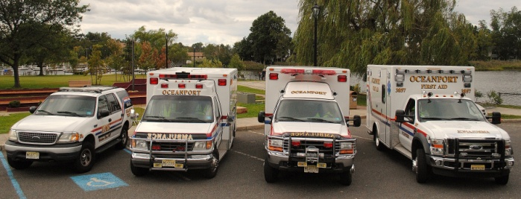

OPFArS- Answering the call to serve.

For over 60 years the members of Oceanport’s First Aid and Rescue Squad have been answering the call to serve. Voluntarily giving their time to come to the assistance of residents in need, from the early hours of the morning to the whiteout conditions of blizzards, OPFARS volunteers are there. This professional response and level of care comes at no cost to those making the call.

Are you interested in answering this noble call? Please continue reading to learn about some of the benefits and incentives of volunteering with-

**‘The Squad’**

volunteering

and its many benefits

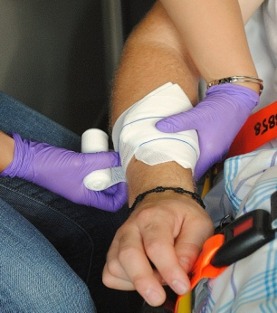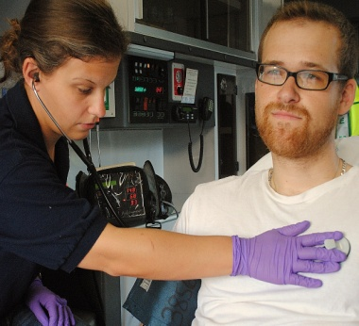

Enter Contact Information Here | 1127 Lombard Blvd. San Francisco, CA 59802 | phone 555.555.5555 | fax 555.555.5555

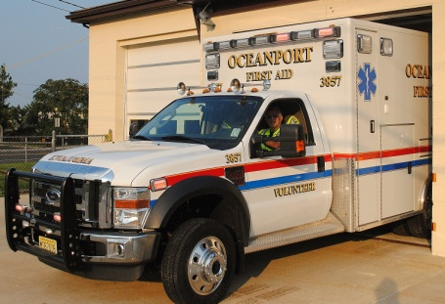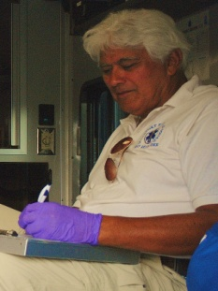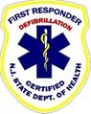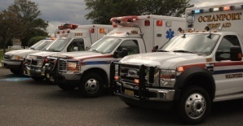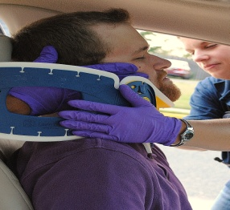

**2010 BY THE NUMBERS:**

704 - Total dispatches

4,651 - Volunteer hours

3,607 - miles logged

172 - mutual aid responses

15 - active members

$0.00- cost to patients

Oceanport Volunteer

First Aid & Rescue Squad

2 Pemberton Ave

Oceanport, NJ 07757-1114

| Phone |

732-544-0864

| Email |

[oceanportfas@gmail.com](mailto:oceanportfas@gmail.com)

[www.oceanportfirstaid.org](http://www.oceanportfirstaid.org)

VOLUNTEER Today-

* Help save lives!
* No experience necessary.
* Free training.
* Financial incentives.
* Contribute to the community.
* Camaraderie.
* Job satisfaction.

A small investment of your time pays dividends. Help keep your family and household safe while supporting your fellow residents of Oceanport.

***Mission Statement***

*The Oceanport Volunteer First Aid & Rescue Squad is committed to providing a timely response to the perceived emergency health needs of our community, 24 hours a day, 7 days a week. While providing basic life-support care and transportation to definitive and/or specialized care facilities at the highest quality level possible at no cost to the patient, with service based on equal availability to all persons.*

“Thank you!!!! For saving my Dad!! Oceanport first aide squad you are so awesome. My father is so happy!!!”

“You are the BEST! Thank you for your rapid response and attention to my son’s needs. Thank you isn’t enough.”

“Now, therefore, be it resolved by the Board of Commissioners of MB that the members of the OPFAS be and are hereby commended and most gratefully thanked for their dedication in serving.”

www.oceanportfirstaid.org

ABLE

“No time is better spent than that spent in the service of your fellow man.”

- Bryant H. McGill

**OPFAS Form 1-1 APR ‘11**

Active members in good standing are exempt from fees associated with recreational programs, building permits, rental of indoor facilities, marriage licenses and more.

Length of Service Award Program (LOSAP)

“To reward the loyal, diligent and devoted service to the residents of Oceanport by emergency service volunteers,” the Borough adopted LOSAP in 2005. The borough makes an annual contribution to a deferred-income account for each member in good standing

Discounted Auto Insurance Rates

Most insurance companies offer reduced insurance rates to those who complete Drivers Safety and/or Emergency Vehicle Operators Courses. Courses are available to members.

*Refer to borough code §103-2

save lives

with the oceanport

first aid & rescue Squad

Access to DEBORAH Heart & Lung Center

Members and their family have free or reduced cost access to DH&L Center’s comprehensive scope of diagnostic tests and quality treatment.

Camelback Resort and Camel Beach

Members and their families can receive discounted tickets to the ski resort and water park.

Working Advantage

Members are eligible to enroll in working advantage for access to discounted tickets up to 40% on everything from movie theaters and Broadway shows to sporting events and hotels.

Network with a wide range of residents.

Contribute to making Oceanport-

‘A Great Place to Live’

And Many, Many More!

WILLING

equipped

tRAINed

Exemption from municipal fees*

benefits and incentives for active members